Application Migration Playbook
Utility
Datacenter to Azure Migration v0.4 — DRAFT, FOR GEHA REVIEW

Utility — descriptor not recorded in the corpus; complete from vendor documentation

Prepared for: G.E.H.A.
John Dean (Director); Dale Gibson (Admin / Support Manager)

Prepared by: Citius Healthcare Consulting
George Galindo, Cloud Architect

Peer Reviewer: Not yet assigned
Document Status: ☒ DRAFT ☐ RELEASE CANDIDATE ☐ PUBLISHED
Date: 26-Aug-2026

1. Document Control
Document control establishes who has changed this playbook, who has approved it, and the standard of evidence every statement within it must meet. It exists so that a reader arriving months after authorship can tell how current the content is, whose judgment stands behind it, and how confident to be in any given figure. The revision history is maintained continuously rather than reconstructed at the end, and approvals are recorded against named individuals rather than teams. Taken together these records make the document auditable without recourse to the people who wrote it.

1.1 Approvers

Name | Role | Approval Date
- | Application Owner
Dale Gibson | Application Administrator
- | Security Lead
George Galindo | Cloud Architect — Citius Healthcare Consulting
- | Migration & Platform Lead (CHC)

2. Executive Summary

Utility application is one wave 1 – The migration scope includes eight active utility servers across the DEV, Test, and PROD environments. These servers operate primarily as shared jump boxes used by support teams to install administrative tools, perform support activities, and run scheduled jobs. The azure target will use windows server 2025 gen 2 virtual machines, UEFI boot, standard azure encryption and storage, and azure hybrid benefit where eligible. The environment does not require static IP addresses, load balancing, or utility specific network tunnels. The principal open items are team-specific software inventory, service and application accounts, certificates of scheduled jobs, network access requirements, and the final disposition of the powered off legacy server LXENTUTl01.

The future state will place the Utility servers on private Azure virtual machines within team-aligned spoke networks connected to GEHA’s existing hub and governed landing zone. Deployment will reuse GEHA’s Azure DevOps pipelines, Bicep modules, security policies, Azure Firewall, NSGs, monitoring, and Cohesity backup platform.

3. Current State
Utility environment consists of eight active servers across the development, test, and production environments. These servers operate primarily as shared jump boxes that various support use to install administrative tools, perform support activities, and run scheduled jobs that should not be executed from users' laptops. The utility environment does not use a load balancer, dedicated network tunnel, or peer connection, and it has no static IP dependency. Standard security agents are installed as required, while additional tools vary by team.
Link- https://lucid.app/lucidchart/e84a11a1-eb65-4751-978a-82ffc74bdb82/edit?viewport_loc=-985%2C69%2C7800%2C2906%2C42U8H5I2Zcsty&invitationId=inv_62a1f34e-fc33-410c-bd80-bfd3a5da28ed
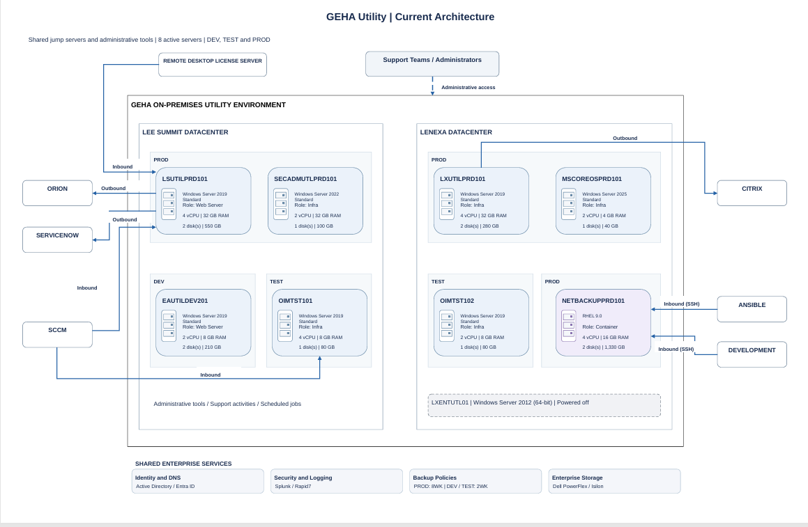3.1 Current State Diagram Flow
Currently we have eight active servers across two data centers, four in Lee Summit and four in Lenexa. These are shared servers that support teams' use for administrative tools, support tools, and scheduled jobs. Across both sites, we have one development server, two test server, and five production servers. At the top, the support teams and administrators access the utility environment to carry out their work. On the left is Lee summit and the two production servers are LSUTILPRD101 and SECAMUTLPRD101. Below them, EAUTILDEV201 is the development server and OIMST101 is the test server. The main connection shown here around LSUTILPRD101 and it receives inbound connections from the Remote Desktop License Server and SCCM. It also has an outbound connection to Orion and ServiceNow. SCCM has another inbound connection to OIMTST101. Lenexa has three production servers LXUTILPRD101, MSCOREOSPRD101 and NETBACKUPPPRD101, and one test Server OIMTST101. LXUTILPRD101 has an outbound connection to Citrix, NETBACKUPPRD101 receives SSH connection from Ansible and the system identified as development in the document. That Server is shown in purple because it runs RHEL 9.0 and host containers. The other seven active servers run windows. As confirmed, the environment has no utility specific load balancer, dedicated tunnel, Peer connection, or static dependency.

4.0 Future State Architecture Diagram
This diagram presents the proposed future-state architecture for the Utility workload following migration to Microsoft Azure. It shows the retained on-premises enterprise services, GEHA Azure landing-zone components, private network connectivity, security controls, monitoring services, and the eight-utility server that will be rehosted as Azure virtual machines. The diagram also illustrates the Azure Migrate replication, testing, cutover, and rollback approach. Final sizing, network addressing, firewall rules, backup configuration and availability requirements will be confirmed during detailed design and migration validation

https://lucid.app/lucidchart/e9e5bb24-6484-423b-b7ca-559485515c07/edit?viewport_loc=-3%2C1128%2C6095%2C2271%2CaZh86zkVYh5Lc&invitationId=inv_12a7bb5a-3dd9-4c7c-a9db-c44afbe9bcb4

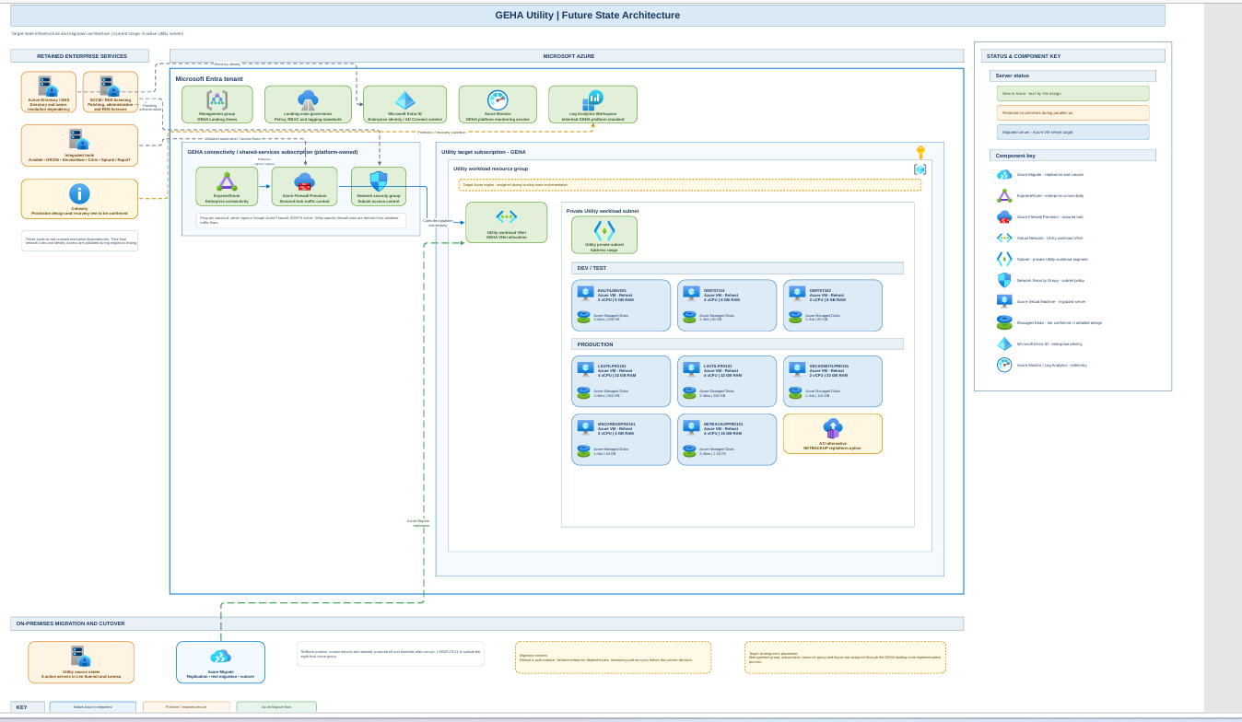

4.1 Proposed Azure Future-State Architecture and Migration Flow

This Future state diagram shows the proposed migration of the utility workload from the on-premises environment into the GEHA azure Landing zone. On the left are the enterprise services that will remain on-premises, including active directory, DNS, SCCM, RDS licensing, Cohesity, and operational tools such as Ansible, Orion, Service now, Citrix Splunk, and Rapid 7. These services will continue to support the workload through approved private connectivity and firewall rules. In the centre is the azure environment. It uses GEHA’s existing Microsoft Entra tenant, landing zone governance, ExpressRoute, and Azure Firewall Premium. The Utility workload will have a dedicated subscription, resource group, virtual network, and private subnet. No public Ip addresses or direct internet access are proposed. The eight active utility servers-three on production and five productions will initially be rehosted as Azure virtual machines. Their current CPU, memory, and storage values provide the sizing baseline, with final Azure configurations confirmed during detailed design. NETBACKUPPRD101 will also be rehosted initially, while container replatforming may be considered later.

At the bottom is the migration approach using azure migration discovery and assessment, replication, isolated test migration, validation, and final cutover. Testing will cover authentication, connectivity, application functionality, monitoring, backup, performance, and business acceptance. After cutover, the original servers will remain powered off but available during the agreed rollback period. Once Azure stability and acceptance are confirmed, the legacy servers will be decommissioned through GEHA’s Standard process

Diagram Name | Utility application
Description | ). The diagram shows the current utility environment, consisting of eight jump servers across the DEV, TEST, And PROD environments at the lee Summit and Lenexa Data centers, It also shows the support teams and shared enterprise services that interface with the servers, No utility-specific load balancer, network tunnel, or peer connection is in use
Use Case | The diagram is used to validate the eight servers included in the utility migration scope, review existing connections and dependencies, support azure migration planning, and brief the migration and cutover teams
Date | 10/15/2026
Sign-Off | Dale Gibson

4.2 Host Resource Specifications
Server / Component | Role | OS / Version | Environment | Assessment Readiness | Holds Data? | CMDB / Asset ID
EAUTILDEV201 | Web Server | Windows Server 2019 Standard | DEV | Active; OS support ends 01-09-2029 (Source: Matilda Discovery Assessment Summary (Host Details / Instance Assessment), as-of 08-Aug-2026) | No | Lee Summit
LSUTILPRD101 | Web Server | Windows Server 2019 Standard | PROD | Active; OS support ends 01-09-2029 (Source: Matilda Discovery Assessment Summary (Host Details / Instance Assessment), as-of 08-Aug-2026) | No | Lee Summit
LXUTILPRD101 | Infra | Windows Server 2019 Standard | PROD | Active; OS support ends 01-09-2029 (Source: Matilda Discovery Assessment Summary (Host Details / Instance Assessment), as-of 08-Aug-2026) | No | Lenexa
MSCOREOSPRD101 | Infra | Windows Server 2025 Standard | PROD | Active; OS support ends 10-15-2034 (Source: Matilda Discovery Assessment Summary (Host Details / Instance Assessment), as-of 08-Aug-2026) | No | Lenexa
NETBACKUPPRD101 | Container | RHEL 9.0 | PROD | Active; OS support ends 05-31-2035 (Source: Matilda Discovery Assessment Summary (Host Details / Instance Assessment), as-of 08-Aug-2026) | No | Lenexa
OIMTST101 | Infra | Windows Server 2019 Standard | TEST | Active; OS support ends 01-09-2029 (Source: Matilda Discovery Assessment Summary (Host Details / Instance Assessment), as-of 08-Aug-2026) | No | Lee Summit
OIMTST102 | Infra | Windows Server 2019 Standard | TEST | Active; OS support ends 01-09-2029 (Source: Matilda Discovery Assessment Summary (Host Details / Instance Assessment), as-of 08-Aug-2026) | No | Lenexa
SECADMUTLPRD101 | Infra | Windows Server 2022 Standard | PROD | Active; OS support ends 10-15-2031 (Source: Matilda Discovery Assessment Summary (Host Details / Instance Assessment), as-of 08-Aug-2026) | No | Lee Summit
LXENTUTL01 | Legacy EA Utility Server — unmapped, disposition required | Windows Server 2012 (64-bit) | Legacy | powered Off; vCenter annotation "Owner: EA Engineers EA Utility Server" (Evidenced — Server_VM_Inventory, LX tab row 191). Unmapped in Matilda and absent from prior revisions of this playbook. Retire-or-ignore ruling required (register W3-UTIL-2). | Retired | Lenexa (vCenter LX tab)

4.3 Sizing & Utilization Baseline
Server | vCPU Allocated | Memory Allocated | Disks (Count / Size / Type) | Peak CPU % | Peak Memory % | Peak IOPS / Throughput
EAUTILDEV201 | 2 | 8 GB | 2 disks / 210 GB | Low% average | Moderate% average | Moderate% storage utilization
LSUTILPRD101 | 4 | 32 GB | 2 disks / 550 GB | Low% average | Moderate% average | Low% storage utilization
LXUTILPRD101 | 4 | 32 GB | 2 disks / 280 GB | Low% average | Low% average | Low% storage utilization
MSCOREOSPRD101 | 2 | 4 GB | 1 disks / 40 GB | High% average | Moderate% average | Moderate% storage utilization
NETBACKUPPRD101 | 4 | 16 GB | 2 disks / 1330 GB | Low% average | Low% average | High% storage utilization
OIMTST101 | 4 | 8 GB | 1 disks / 80 GB | Low% average | Moderate% average | High% storage utilization
OIMTST102 | 2 | 8 GB | 1 disks / 80 GB | Low% average | Moderate% average | High% storage utilization
SECADMUTLPRD101 | 2 | 32 GB | 1 disks / 100 GB | Low% average | Moderate% average | High% storage utilization

4.4 Network
The Utility servers are administrative jump boxes accessed directly through RDP. Utility does not use a load balancer, shared virtual IP address, shared application URL, or dedicated Utility VPN. On-premises users connect through the existing ExpressRoute path, while remote users connect through Zscaler. No static-IP dependency has been confirmed.

DNS Records | Individual server DNS records must be identified and validated. Utility does not have a shared application DNS name.
Firewall Rules to Remove | Network access requirements vary by support team because different administrative tools are installed on each server. Required traffic includes RDP, SMB, and, where applicable, SQL ports 1433 and 1434. Discovery also observed ports 443, 9998, 135, 389, and 8089. The final source, destination, port, protocol, and direction matrix has not yet been confirmed.
External / Partner Connectivity | No external or partner connectivity has been confirmed for Utility.

4.5 VPN & Remote Connectivity
Utility Remote access and site-to-site connectivity are treated separately here because they behave differently after a move to Azure. Remote access requirements change rather than disappear, and the answer depends on the connectivity model chosen in the target design, including whether traffic to Azure endpoints is forced back through the corporate tunnel — a frequent and avoidable cause of post-cutover performance complaints. Site-to-site tunnels are jointly owned with external organizations, so their encryption domains, authentication material and far-end contacts are recorded with the lead time each partner's change process requires. Where this application was the only reason a population held VPN access, that access is reviewed rather than left in place.

Is Remote Access VPN Required to Reach the Application? | No
Solution & Client | Zscaler for remote access
Concentrator / Gateway | Not yet provided — Device or service terminating the connection, and the team that owns it. Not on file in the evidence pack (searched per the Appendix B source-exhaustion note, 26-Aug-2026); requested from GEHA (Appendix B; register W3-UTIL).
Authentication to the VPN | no Utility-specific VPN gateway
Split Tunnel Behavior | Not applicable to Utility
Still Required After Cutover? | ☐ Yes ☐ No ☐ Only for other applications —EpressRoute for on-premises access and Zscaler for remote access
Table 4.6.1a — Remote Access VPN

Each site-to-site tunnel is registered individually because changes at the far end are outside GEHA's control and run to the partner's timetable, not the program's. The register records what traffic the tunnel carries, its encryption domain, the device terminating it, the authentication material and its expiry, and a named contact at the far end together with their required notice period. Tunnels shared with other applications are identified explicitly so they are not retired alongside this one. Each tunnel resolves to retirement, retention or modification, and that disposition is agreed with the partner before the cutover window opens.

4.6 Integration and Dependencies
Utility servers connect to several GEHA enterprise services for administration, monitoring, automation, licensing, and support. The connections below were observed in the current environment. They identify systems that must remain reachable after migration but do not represent the final firewall-rule matrix

System | Direction | Protocol / Method | Frequency | Owning Team (Far Side) | Criticality
ORION | Outbound | observed on ports 49847… (svchost) | 83 connection rows | - | Low
SCCM | Inbound | observed on ports 60640… (dllhost) | 7 connection rows | - | Low
REMOTE DESKTOP LICENSE SERVER | Inbound | observed on ports 64365… (svchost) | 2 connection rows | - | Low
SERVICENOW | Outbound | observed on ports 63634… (svchost) | 2 connection rows | - | Low
ANSIBLE | Inbound | observed on ports 55586… (sshd:) | 2 connection rows | - | Low
DEVELOPMENT | Inbound | observed on ports random/none… (sshd:) | 1 connection rows | - | Low
CITRIX | Outbound | observed on ports 59417… (svchost) | 1 connection rows | ).Different teams on this application to be determined | Low

4.7 Data Classification
The Utility servers are administrative jump boxes used by support teams to install management tools, perform support activities, and run scheduled jobs. They are not intended to store application or business data. No PII, PHI, or PCI data has been identified on the Utility servers.

Data Sensitivity | internal
PII / PHI / PCI Present | NO – utility servers are jump boxes and are not intended to store application or business data

4.8 Migration Strategy
The confirmed migration strategy for Utility is to rehost the eight active servers as Azure virtual machines. This is an infrastructure migration; the servers will continue to function as administrative jump boxes, and no application redesign is planned. LXENTUTL01 is powered off, is excluded from the migration scope, and will be retired.

Component | Strategy | Target Service
Active Utility servers  NETBACKUPPRD101 container workload  LXENTUTL01 | Rehost  Rehost or replatform  Retire | Azure virtual machines

4.9 Landing Zone Placement
Landing zone placement records where this workload deploys and, just as importantly, what it inherits by deploying there. The management group, subscription, resource groups, region and paired region are captured together with the naming and tagging standards the workload must satisfy. Inherited policy is called out explicitly because it constrains deployments in ways invisible to the application team and is a frequent cause of failures that appear inexplicable at build time. Quota, SKU and zone availability in the target region are confirmed before design sign-off rather than discovered on the day of deployment.

Management Group | To be determined
Subscription Name & ID | Proposed, not final: Resources will be separated by owning team. Cloud and Platform Services may have one subscription, with other teams using their respective subscriptions.
Resource Groups | Not yet provided
Primary Region & Paired Region | Not yet provided
Naming Standard | GEHA has a documented naming standard and agreed to share it. The actual naming values are still pending.
Tagging Requirements | Not yet provided —
Inherited Policy Assignments | 42 policy assignments exist in the tenant and will apply at the scope this workload lands in.
Policy Exemptions Required | Not yet provided)
RBAC Scope for the Workload Team | The migration team can contribute to GEHA’s existing repositories after working sessions with the platform team. Exact Azure roles and access still require confirmation.
Quota & Capacity Confirmation | Not yet provided

5.0 Proposed Azure Network Design
The Utility servers will be deployed within the approved GEHA Azure virtual network and subnet. The servers do not require static IP addresses, load balancing, or Utility-specific tunnels or peer connections. Connectivity will be limited to administrative access and required enterprise services, including Active Directory, DNS, security agents, monitoring, patching, and team-specific tools. On-premises connectivity to the Utility servers will use GEHA’s existing ExpressRoute connection, while remote users will access the environment through Zscaler. Authorized support teams will connect directly to their assigned servers through RDP, with administrative tools installed locally on each server. Utility does not use a shared application URL or virtual IP address. Azure Firewall and NSG rules will be required for each team, including RDP, SMB, and SQL ports 1433 and 1434 where applicable. The final source, destination, port, protocol, and direction requirements must be confirmed with each server owner.

Virtual Network & Subnets | Utility will use the approved GEHA Azure virtual network and subnet. The spoke will connect to the existing Azure hub. Exact VNet, subnet names, and CIDR ranges are not yet documented.
IP Addressing | Static IP addresses are not required. The servers will use private IP addresses. Exact assignments are not yet documented.
Connectivity to On-Premises | Existing GEHA ExpressRoute connectivity. Remote-user access will use Zscaler.
Hub / Spoke Peering | he Utility spoke will connect to GEHA’s existing Azure hub. Exact peering configuration is managed through the established landing-zone process.
Network Security Groups & Application Security Groups | NSGs are required, but the final rules were not confirmed
Route Tables & Forced Tunnelling | Not yet provided
Firewall / Egress Control | Utility traffic will use GEHA’s existing Azure Firewall controls. Team-specific firewall rules still need to be confirmed.
Private Endpoints & Private DNS | Not applicable to the current VM-only Utility design. No PaaS services were identifie
Load Balancing | No load balancer
Web Application Firewall | Not applicable. Utility does not provide a web application endpoint..
DNS Records | Individual server DNS records are required. Utility does not use a shared application FQDN. Exact records and TTL values still need confirmation.
Certificates | No Utility- Specific certificate requirement has been identified
Table 5.6 — Network

5.1 Security & Compliance
Utility will inherit GEHA’s existing Azure landing-zone security policies and controls. Network traffic will be protected by Azure Firewall and NSGs, and the servers will use GEHA-approved security, monitoring, and patching agents. The Utility servers are classified as internal and are not intended to store application or business data. No PII, PHI, or PCI data has been identified.

Cloud Security Posture Tooling
  Existing GEHA Azure policies, Azure Firewall, and NSGs will apply.
Endpoint  Protection | Not yet provided — Product on the target servers, and how it is deployed. Not on file in the evidence pack (searched per the Appendix B source-exhaustion note, 26-Aug-2026); requested from GEHA (Appendix B; register W3-UTIL).
Encryption at Rest | Standard Azure storage encryption will apply.
Encryption in Transit | existing GEHA secure network paths, including ExpressRoute and Zscaler, will be used.
Security Log  Collection | Monitoring and security agents are required. The final logging destination needs confirmation.
Vulnerability Management | The GEHA standard will apply; the scanning tool and remediation process need confirmation.
Patching Approach | The GEHA standard patching process will apply; the maintenance schedule needs confirmation.
Compliance Obligations
  Internal classification; no PII, PHI, or PCI data has been identified.
Data Residency Confirmation | The Azure region and backup location still need confirmation
Table 5.8 — Security & Compliance

6.0 Rollback
The on-premises Utility servers will remain intact and available until the Azure servers have passed connectivity, access, security, monitoring, backup, and owner-validation testing. If a critical issue prevents the Azure servers from supporting administrative activities, the Azure Utility servers will be stopped, and users will be directed back to the on-premises servers.

Rollback activities will include restoring the original DNS and firewall configuration, confirming RDP access to the on-premises servers, and validating the required administrative tools and enterprise-service connections. Because the Utility servers are not intended to store application or business data, no business-data synchronization is expected. Any configuration changes made after the Azure cutover must be documented and reapplied if rollback occurs. The rollback decision deadline and source-server retention period still require approval.

6.1 Sign-Off
Approval to execute is recorded here, and each signatory is a named individual accountable for the sections relevant to their role rather than a representative of a team. Signing confirms that the target design, the cutover plan and the rollback position documented in this playbook are approved for execution as written. Signatures are obtained before the go/no-go gate rather than retrospectively. A playbook signed on this basis is the authority under which the cutover proceeds.
By signing below, stakeholders confirm that the target design, cutover plan and rollback position documented in this playbook are approved for execution.

Name | Role | Date
- | Application Owner
- | Migration / Technical Lead
George Galindo — Cloud Architect, CitiusTech | Platform / Cloud Lead
- | Security

Christy Ammel (DBA / Production Control) | DBA / Production Control
 | Network
Table 12 — Sign-Off

